**Part 2**

**For the confusion matrixes of task 1,3,5, please go Question 1 section.**

**Task 2:**

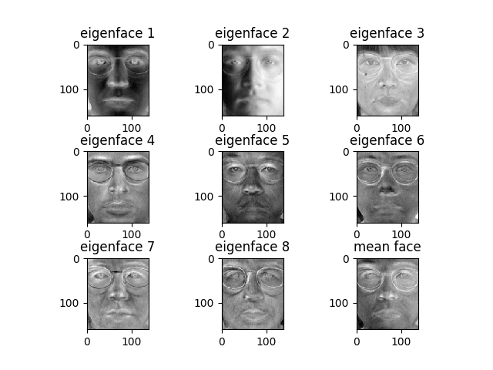

**Task 4:**

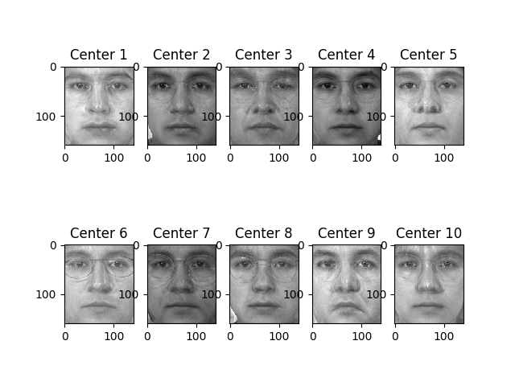

**Question 1:** **Print the confusion matrix and overall accuracy for three identifiers.**

**Overall Accuracy:**

|  |  |  |  |
| --- | --- | --- | --- |
| IDENTIFIERS | PCA | LDA | Fusion |
| ACCURACY | 0.74 | 1.0 | 0.76 |

**Raw image:**

C:\Users\Long Zhang\AppData\Local\Microsoft\Windows\INetCache\Content.Word\task_0_overall _accuracy_of_three_classifiers.png

**Confusion Matrixes for Task1,3,5:**

Task 1:

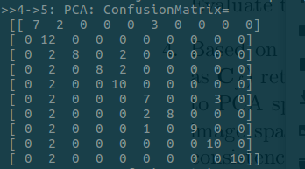

Task 3:

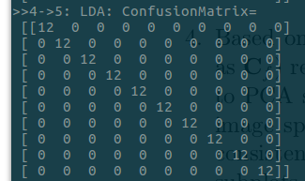

Task 5:

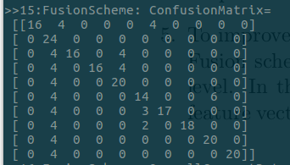

**Question 2**: **Compare the results for PCA feature and LDA feature, which feature is better? Why?**

LDA is better. From the definition of PCA and LDA, we can know that LDA trying to separate every classes , but PCA just split averagely on every samples. Therefore, in this case, LDA is better than PCA.

**Question 3:** **Let α = 0.1, 0.2, . . . , 0.9. Retrain your identifier for fused feature and re-calculate its accuracy for each α. Plot accuracy versus α for different α. Submit this plot. What do you observe?**

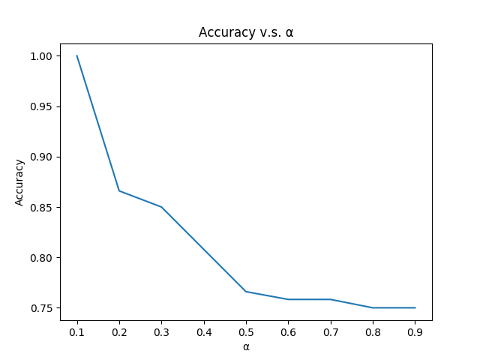

As the weight changes, the overall accuracy is changing, more precisely, the overall accuracy is influenced most by the LDA feature. After LDA feature is almost terminated, the accuracy will be stable at around 0.75, which means PCA has little effects on it by changing the weight of PCA.

**Question 4:** **Does the fused feature outperform both PCA feature and LDA feature? Why?**

Yes, from my test result, the fusion scheme is better than PCA, might worse than LDA. Previously, LDA is better than PCA before we combine them two. With an equally weight on both features, we get an accuracy in the middle of PCA and LDA. In other words, with the adjustment of weight(alpha),we can get a better accuracy, combine the pros of PCA and LDA.